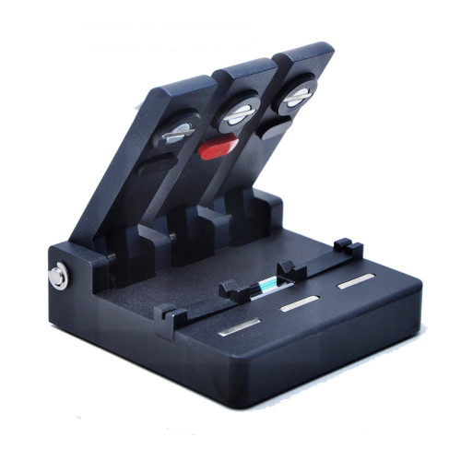

Fiber Connector V3
V3 fiber connector is mainly used for active coupling connection of bare fibers in fiber testing, experiment, construction and fiber optic single disk test.
The utility model has the advantages of simple structure, reliability and convenient operation.
Features & Specifications
V3 locates fiber with high precise V-groove and makes two fibers align, the loss is less than 0.5dB (same SMF). The two adjustable site-seats can be applied to all kinds of coated fibers.
Dimension: 90mm (W) x70mm (D) x24mm (H)
Weight:260g
Instructions
- Preparation of fiber endface
Stripping the connecting fibers, make sure its length around 40mm, then clean them with alcohol cotton. Using fiber cleaver to cut the stripped fibers, and make sure its length around 10mm.

- Placing fibers
Placing one stripped fiber into V-groove from the left side, make sure the fiber’s endface in the middle of V-groove, then put down the left fiber holder to press fiber tightly; Before placing another stripped fiber into V-groove from the right side, please dipping some matching oil on its endface, push it forward to touch left fiber’s endface closely, then put down middle and right fiber holders.

- Marks
Do not use hard objects to collide and scrape the V-groove, in case of any damage.
The V-groove must be wiped off with an alcohol stick before using

